Project Report

Version 1.0

December 3, 2021

Online Auction System
Abhirup Bhattacharya (AXB200027) Manasi Vivek Gosavi (MVG200001)
Vamshidhar Reddy Komandla (VXK200007) Vamsi Sai Tumu (VXT210007)

Submitted in partial fulfillment Of the requirements of
CS 6360 Database Design

Table of Contents
Contents
1.Introduction: 3
2.System Requirements: 3
2.1. Context Diagram: 3
2.1.1 Context Diagram for Administrator 3
2.1.2 Context Diagram for Buyer 4
2.1.3 Context Diagram for Seller 5
2.2. Interface requirements: 5
2.3. Functional requirements: 5
2.3.1. Login Functional Requirements: 5
2.3.2. Buyer Functional Requirements: 5
2.3.3. Seller Functional Requirements: 6
2.3.4. Administrator Functional Requirements: 6
2.4 Non-functional requirements: 6
3. Conceptual Design of the Database: 7
3.1. Entity Relationship model: 7
3.2. Data dictionary and business rules: 8
4. Logical Database Schema: 8
5. Functional Dependencies and Database Normalization: 8
6. The Database System 8
7. Suggestions on Database Tuning (optional) 8
8. Additional Queries and Views 8
9. User application interface 8
10. Conclusions and Future Work 8
11. References 8

1.Introduction:

This software system will be an Online Auction System, to be used by sellers to advertise their products and for potential buyer to submit their bids, with the highest bidder automatically being selected as the buyer. This system will be designed to provide a platform for the sellers to find the best price for their products. At the same time, it will provide a fair opportunity to all the potential buyers to offer their best price and get a chance to buy the product. The system will meet the needs of the buyers and sellers, while remaining easy to understand and use. Additionally, the system will also provide privileges to the administrator to have complete control of the users and the content posted.

2.System Requirements:

2.1. Context Diagram:

2.1.1 Context Diagram for Administrator

2.1.2 Context Diagram for Buyer

2.1.3 Context Diagram for Seller

2.2. Interface requirements:

2.3. Functional requirements:

2.3.1. Login Functional Requirements:
- System will allow users to create account.
- System will verify the username and password.
- System will allow the user to login.
- System will not allow user to login with invalid username or password.
- System will be able to remember username and password.
- System will allow users to retrieve password in case users forget password.
- System will enable users to logout of their accounts

2.3.2. Buyer Functional Requirements:
- System will allow user to search for available products.
- System will also allow user to search for seller and check available products.
- System will show the new products available for bid on login.
- System will always show most recent bid price for a product.
- System will allow the bidder to bid on desired product multiple times.
- System will allow users view their active bids.
- System will allow users to view their expired bids.
- System will allow users to view their purchase history.
- System will allow users to provide feedback on the purchased products.
- System will allow users to report offensive products.
- System will allow users to cancel bid offer.
- System will allow users to contact seller.
- System will allow users to contact admin.

2.3.3. Seller Functional Requirements:
- System will allow users to add advertisements for product they want to sell.
- System will allow users to modify the advertisements.
- System will allow users to delete the advertisements.
- System will show users the messages received from buyers and allow user to respond to them.
- System will allow users to provide feedback.
- System will allow users to view history of sold products.
- System will allow users to contact admin.

2.3.4. Administrator Functional Requirements:
- System will allow admin to view all products.
- System will allow admin to control and delete any product.
- System will allow admin to add new categories to database.
- System will allow admin to modify existing categories or delete categories.
- System will allow admin to view all users.
- System will allow admin to add announcements visible to users.
- System will allow admin to view and respond to messages.
- System will allow admin to view reported products and take action(modify/delete).
- System will allow admin to verify sellers.

2.4 Non-functional requirements:

Performance:
- UI Response time: Each request will be processed in under 10sec
- DB query time: DB queries to be processed under 5 sec
- Reboot time of 30min
- Client-side data validation & business logic implementation
- Data caching is to be implemented for webservices with cache clearing every 10min

Scalability:
The web service load can be scaled up on-demand

Capacity:
The website will be able to accommodate 20 concurrent users

Reliability/Availability:
The services will be hosted locally, so they would be available on demand

Security:
HTTP basic authentication with Username and Password

Maintenance:
Database maintenance will be done during the pre-communicated downtime hours

Data retention/encryption:
The order/advertisement data will be retained and archived every 30 days
KYC data, Usernames, passwords are to be stored in encrypted format

3. Conceptual Design of the Database:

3.1. Entity Relationship model:

3.2. Data dictionary and business rules:

User_Id – Assigns a unique number to everyone who registers. This is the primary key for the table.

Email – The email of the user

Password-The password for the user

User Type – Type of user (Admin, Seller, Buyer)

User Status – The Status of user either he is active or inactive.

Username: The Name given or created by the User.

Phone: User’s phone number

Communicates: communication is done through messages

Seller: the user who sells products in the auction

Seller Account details: the details of the seller account.

Seller Account: the type of the account seller is using such as business or personal account.

Account: The account number of the seller

Routing Number: Routing Number of the seller’s account

Company EIN: Employer Identification Number (EIN) must be unique.

Company Name: Name of the seller’s company.

Buyer Name: The first and last name of the buyer

fName – The first name of the Buyer

Lname: The last name of the Buyer.

date_of_birth: The user’s date of birth of Buyer.

Card Details: The Card Details of the Buyer(Composite attribute)

Card Expiry Date: The Expiry date for the card of the buyer

Mailing Address: the mailing address contains different attributes like Street Name, Apt Number, City, State, Country, Zip code.

Bids_on : The Bids_on contains different attributes like Bid Time, Bid Amount, Bid_id.

Product: The product has different attributes like product name, base price, ProductID, product description, posting date, increment value, auction start date, auction end date,.

Transaction: The transaction has multiple attributes like Txn_id which is unique, txn_date, txn amount, shipping date, txn_status, seller feedback and buyer feedback

Advertises: The product advertisement is done by the seller

Manages: Admin manages the category

Category: Category contains different attributes such as creation date, category name , category ID

4. Logical Database Schema:

5. Functional Dependencies and Database Normalization:
USER:
UserID -> EmailAddress, UserName, Password, UserStatus, UserType
EmailAddress -> UserName, UserStatus, UserType, Password
UserName -> EmailAddress, UserStatus, UserType, Password

BUYER:
UserID -> SSN, FirstName, LastName, DateOfBirth, Street_name, Apartment_Number, City, State,
Country, ZipCode, Card_number, Card_ExpiryDate
SSN -> FirstName, LastName, DateOfBirth
Card_number -> Card_ExpiryDate

SELLER:
UserID -> Company_name, Company_EIN, AccountType, Account_number, Routing_number, Employee_id
Company_EIN -> Company_name
Account_number -> Account_Type, Routing_number

ADMIN:
UserID -> Employee_ID

PRODUCT:
Product_ID -> ProductName, Product Description, PostingDate, Auction_Start_Date, Auction_End_Date, BasePrice, Increment_value

TRANSACTION:
Txn_ID -> Buyer_ID, Seller_ID, Txn_Date, Txn_Amount, Txn_Status, Buyer_comment, Buyer_Rating, Seller_comment, Seller_rating, Shipping_date

CATEGORY:
Category_ID -> Category_name, Category_parent, Creation_Date
Category_name -> Category_parent

BID:
Bid_id -> Buyer_id, Product_id, Bid_amount

6. The Database System

Database server installation:

Please download and install MySQL 8.0.13 from the below link

https://dev.mysql.com/downloads/mysql/

Screenshots of how to use the database.

USER:
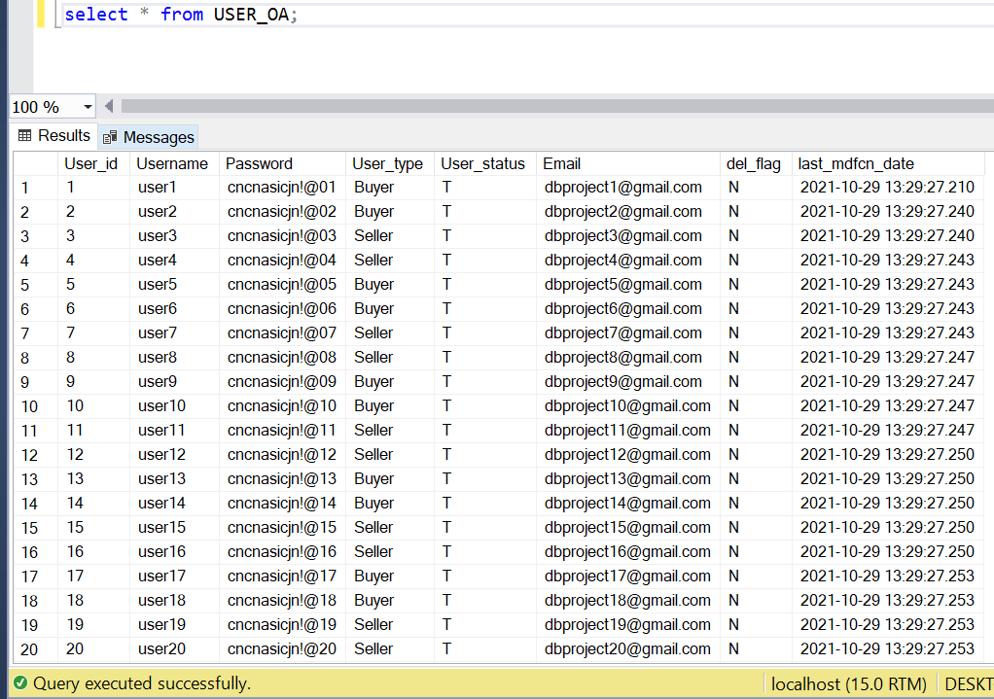

BUYER:
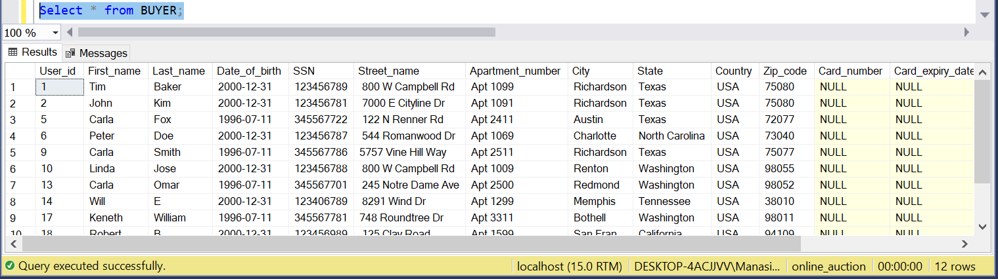
SELLER:
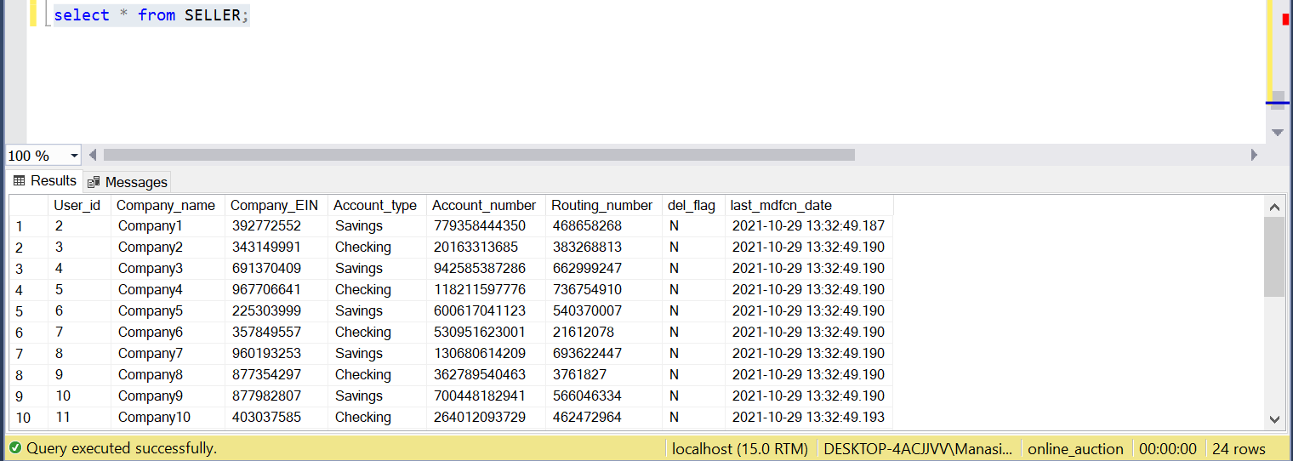
ADMIN:
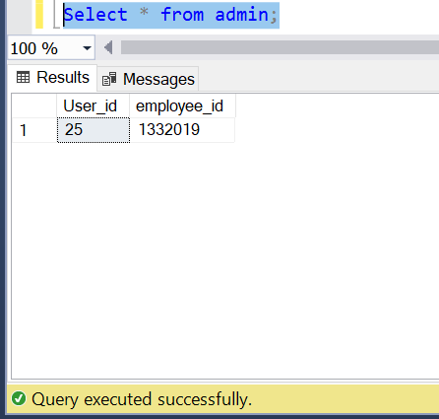

PHONE_INFO:
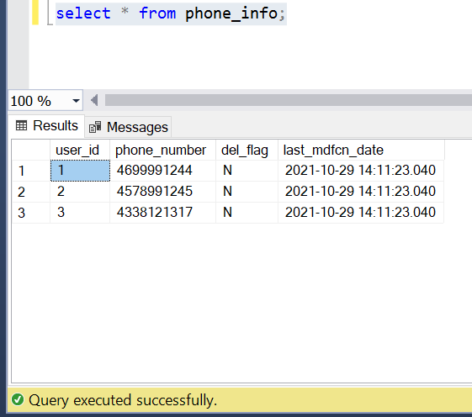
CATEGORY:
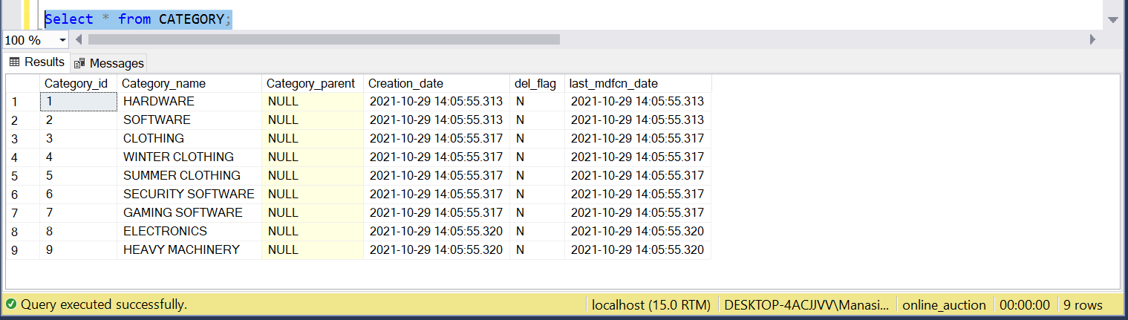

PRODUCT:
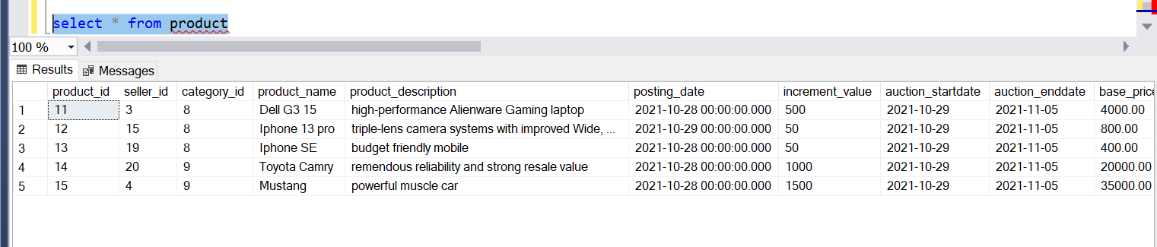
BID:
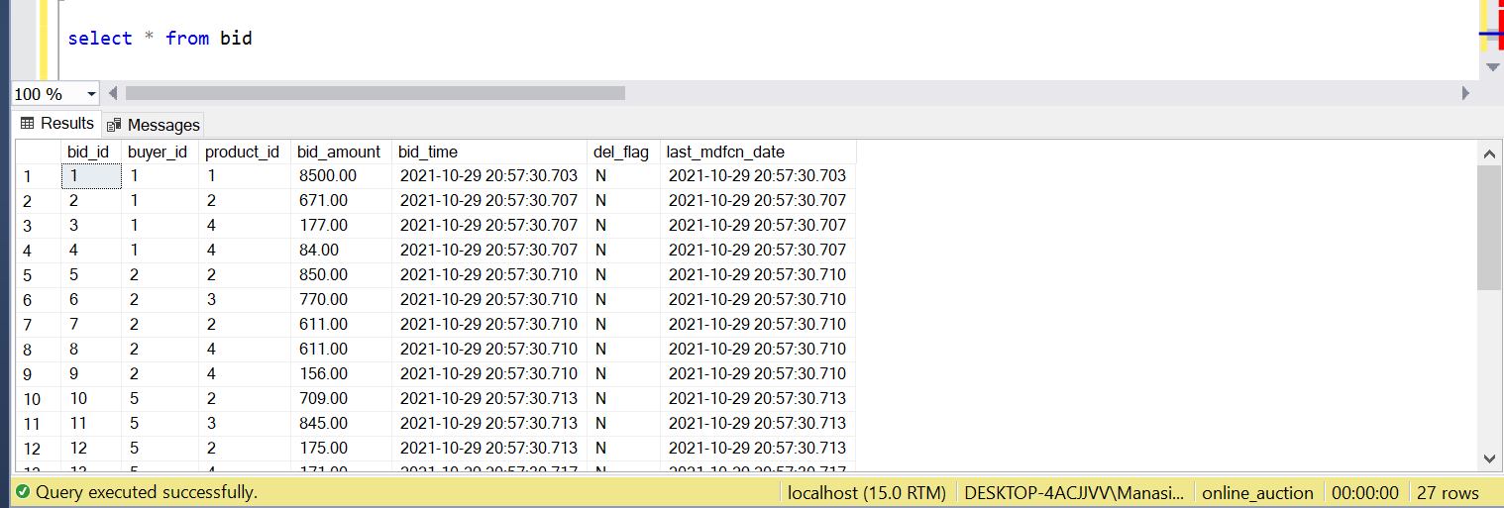

TRANSACTIONS:

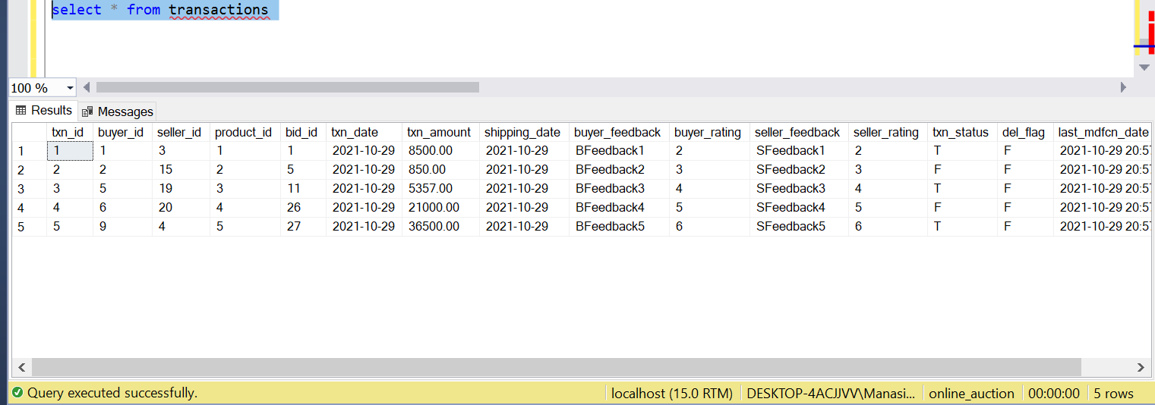

7. Suggestions on Database Tuning (optional)

We created an Index on Products table since we frequently query the products based on a seller.

create index PRODUCT_SELLER_IDX on PRODUCTS(SELLER_ID);

Since the bids for a given user are queried in real time, creating an index of BUYER_ID in the BIDS table improves performance.

create index BID_SELLER_IDX on BIDS(BUYER_ID);

8. Additional Queries and Views

Queries:

The below query gives us all the underlying child category types for a given parent id:

select category_name from
(select * from category order by category_parent, category_id) category_sorted,
(select @pv := '11') initialisation
where find_in_set(category_parent, @pv)
and length(@pv := concat(@pv, ',', category_id));

The below query gives the highest bid so far on a given product id:

SELECT * FROM bid where product_id = 1 order by bid_amount desc limit 1;

Query to check Transaction history of seller:

select s.user_id,p.product_name,p.product_description, t.txn_amount
from product as p, transactions as t, seller as s
where p.seller_id = t.seller_id and s.User_id = p.seller_id and t.seller_id =1;

Query to get the maximum bid so far on a given product id:

select max(bid_amount),product_id from bids where bid_endtime < current_timestamp() group by product_id;

Views:
create view active_product as
SELECT product_name,product_description,auction_startdate,auction_enddate FROM bid b,product p,buyer bu where b.product_id=p.product_id And b.buyer_id = bu.user_id And datediff(day,p.auction_enddate,current_timestamp) < 0;

9. User application interface

User Interface Screenshots for Buyer

- Creating an account -> All the details filled in the form are inserted to USER table and BUYER/SELLER depending on the values selected when creating account.
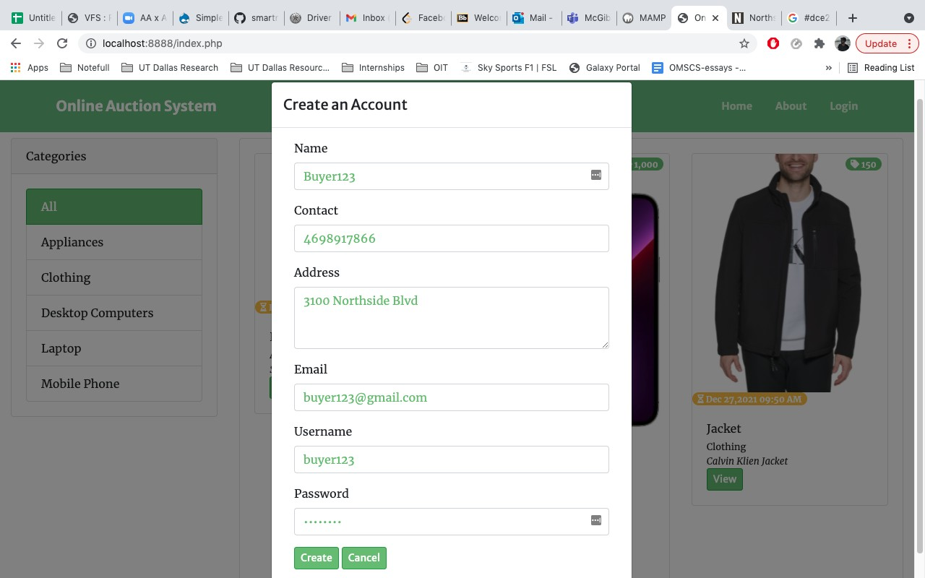
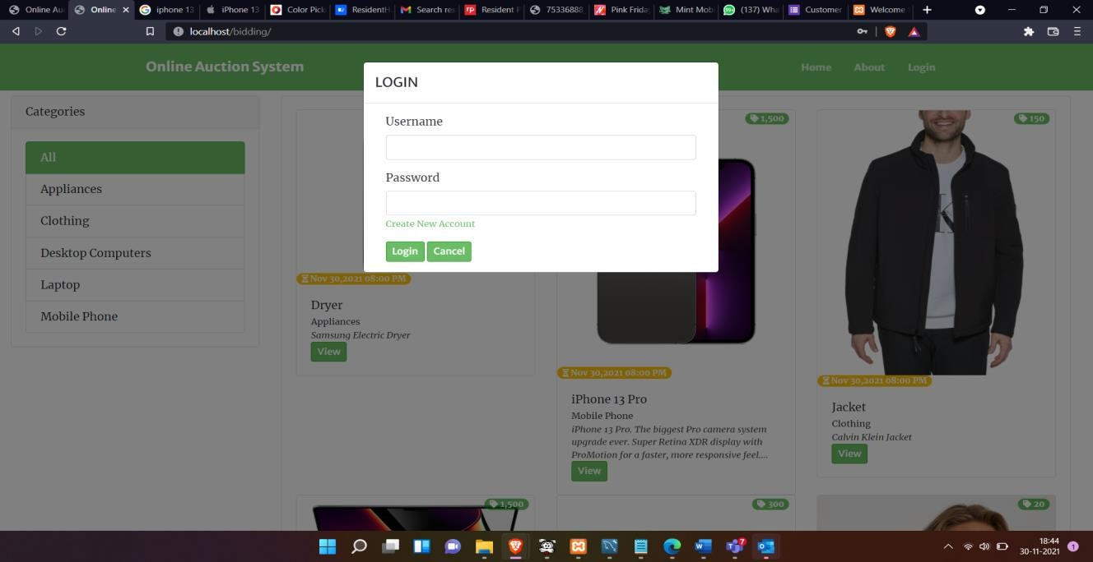
  - User login -> Verifies the username and password from the database and validates the user login.

- Display products -> Retrieves the entries from join of Products and Categories table based on the category given. Selects all products where All category is chosen.
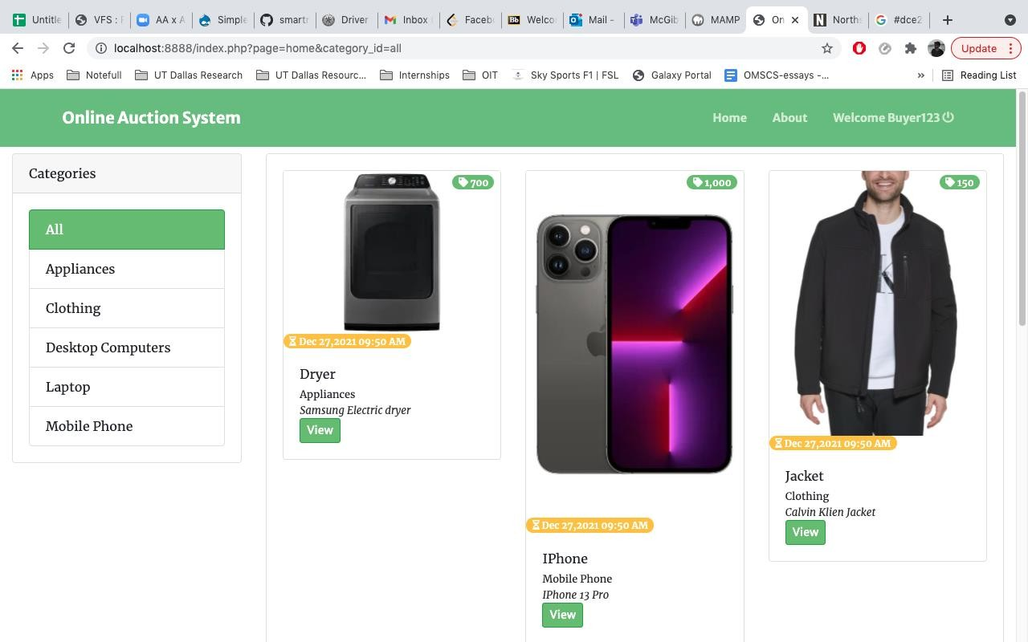

- Bid on product -> Inserts the records to Bids table.
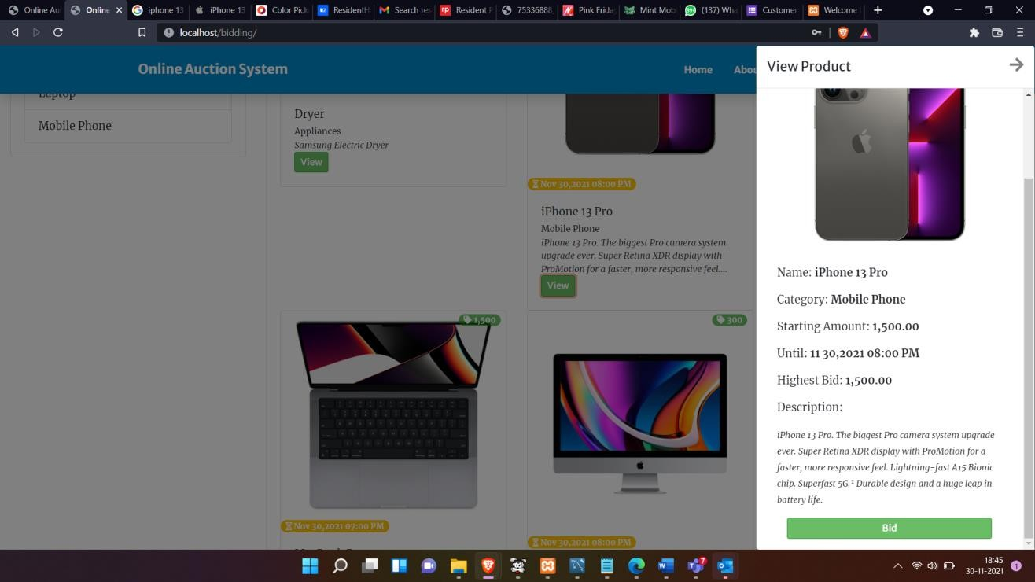

- Bid not placed as amount less than current highest bid
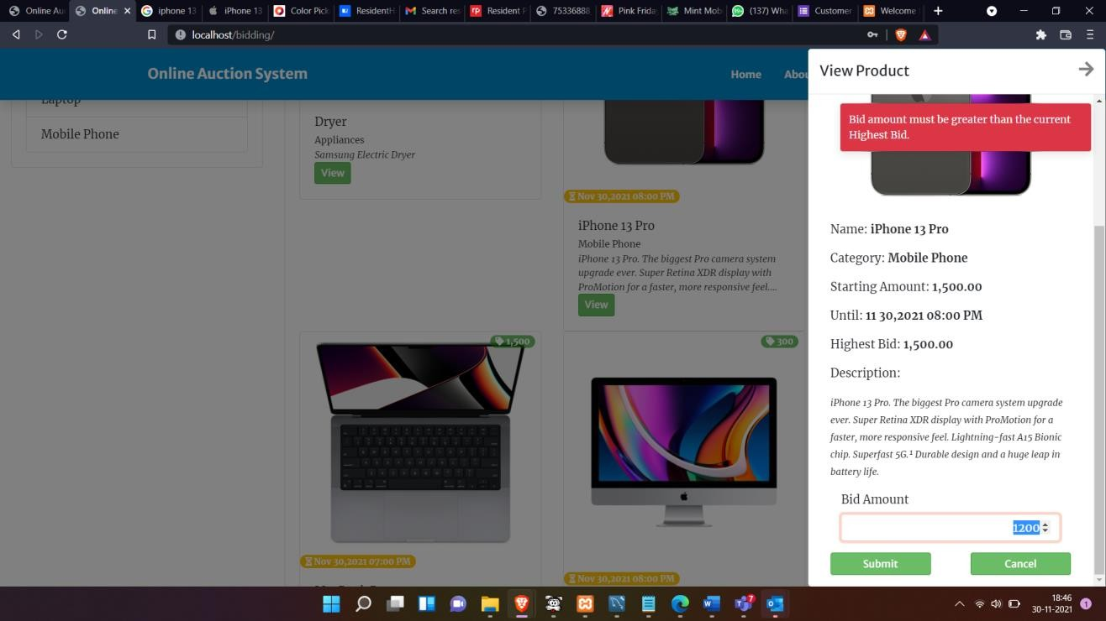

- Bid placed
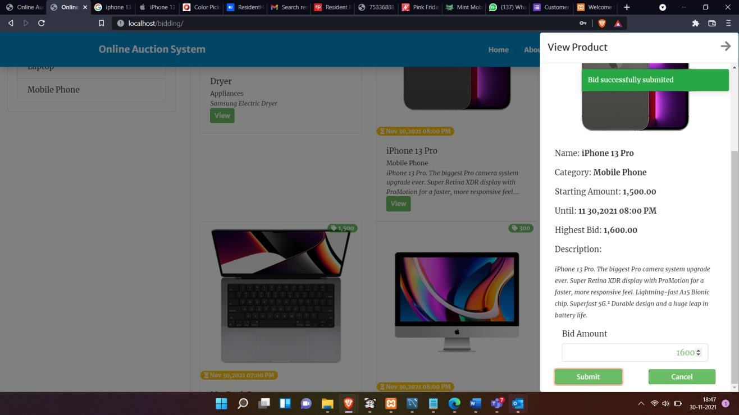

User Interface Screenshots for Seller

- Seller homepage
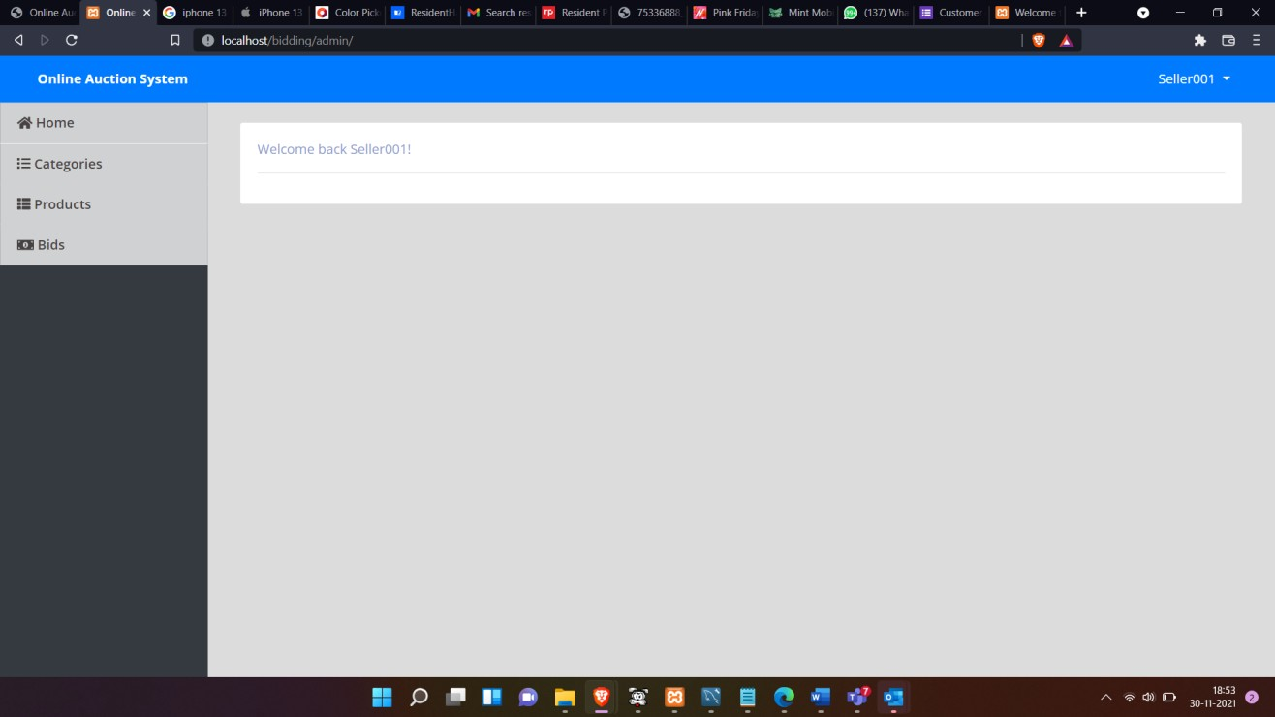

- Add products for bid -> Inserts the product details to Products table and stores the images on to the web server image location.
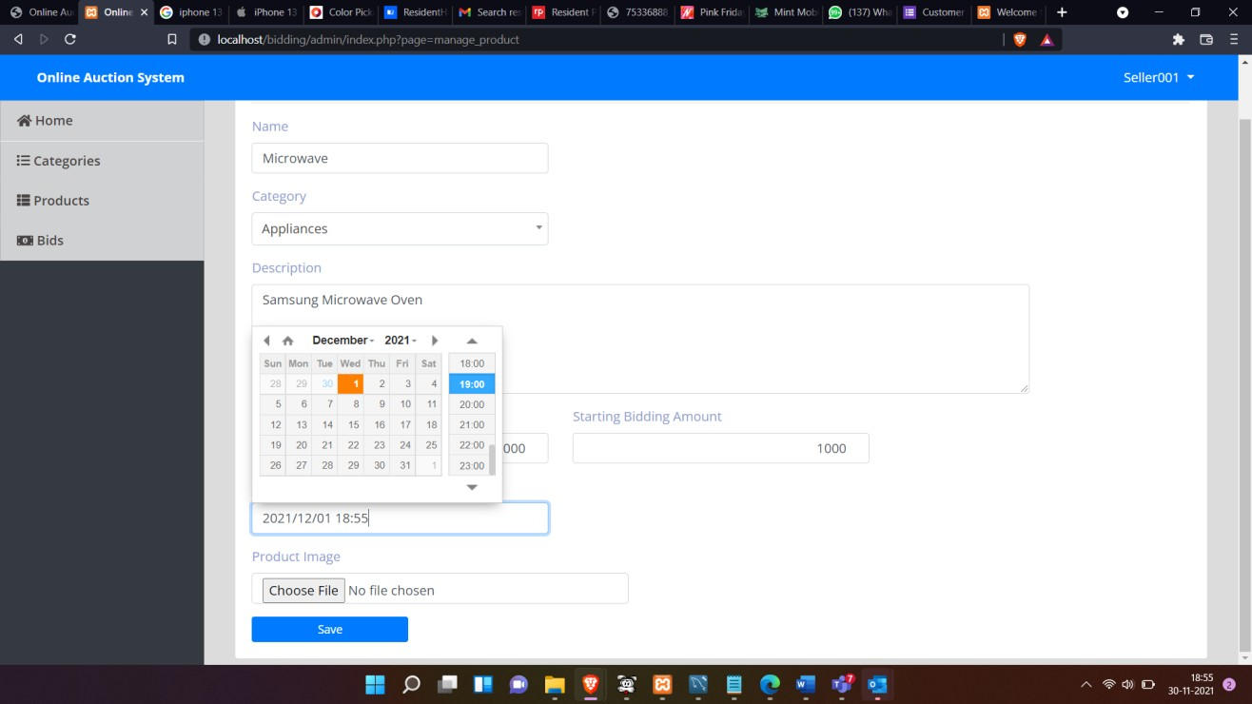

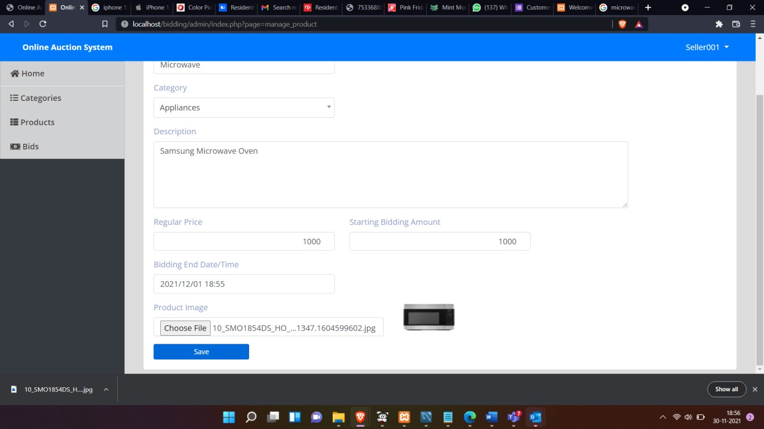

- View highest bid on product -> Retrieves the data using the query mentioned in Additional queries section.
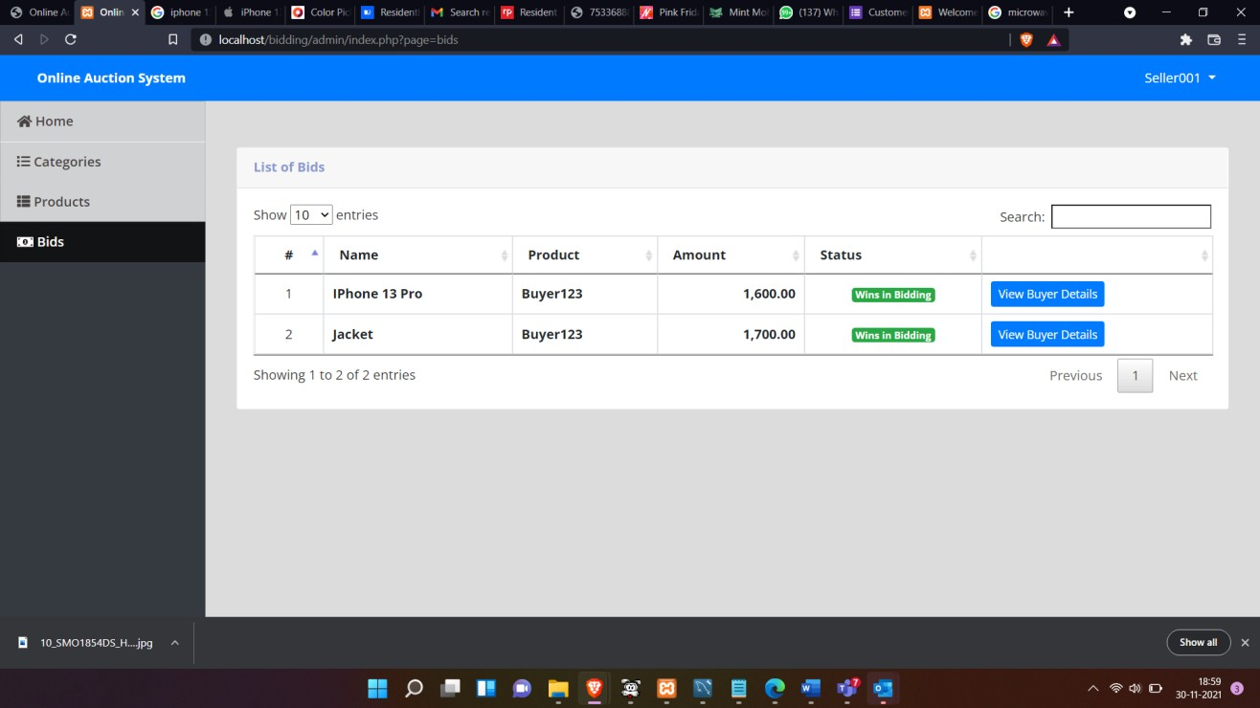

View buyer details -> Gets the data from BUYER table
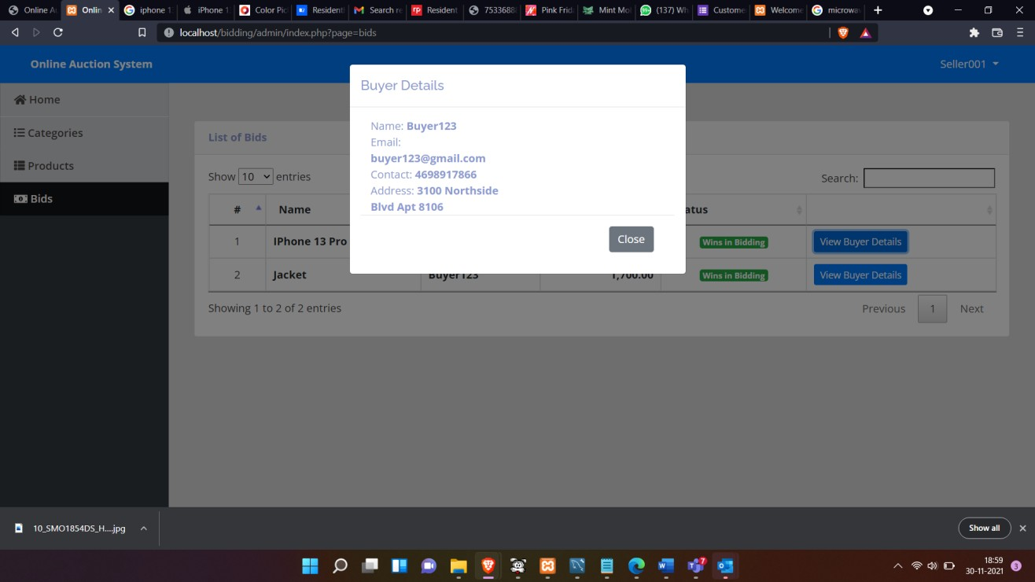

User Interface Screenshots for Administrator

- Administrator homepage
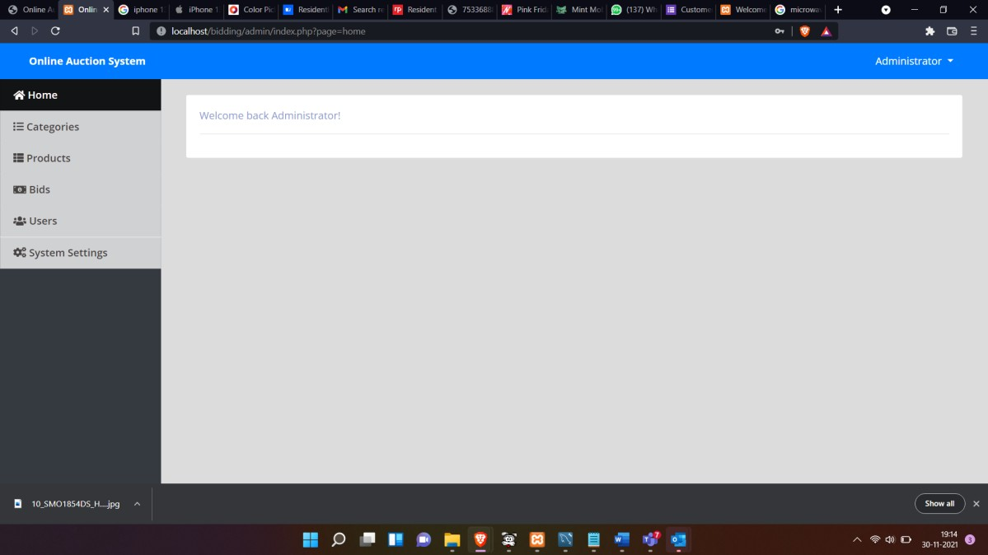

- Add category -> Inserts data to Categories table
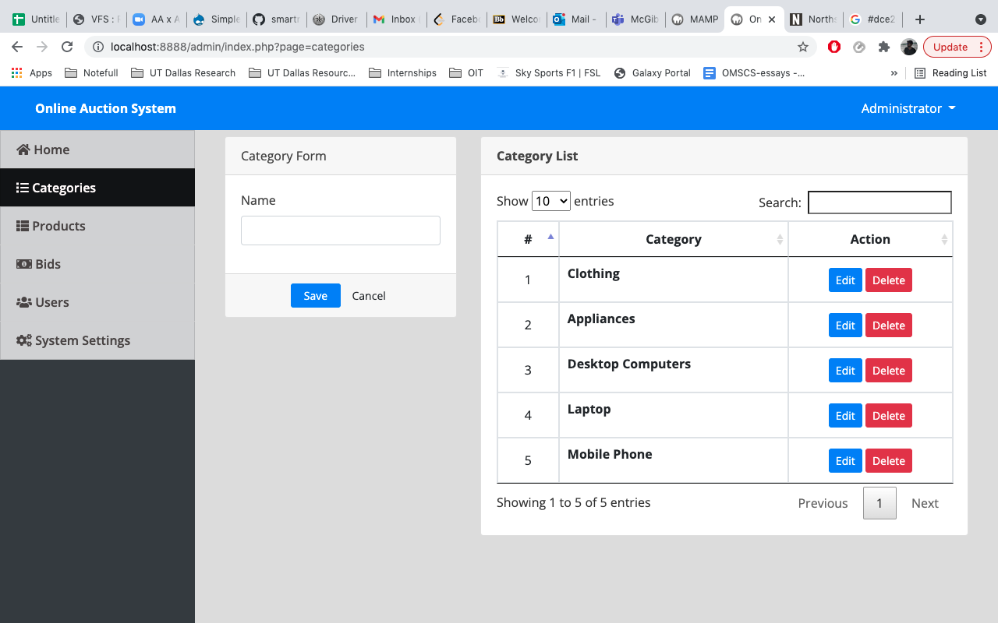

- Filter products -> Filters the products based on the product name from Products table
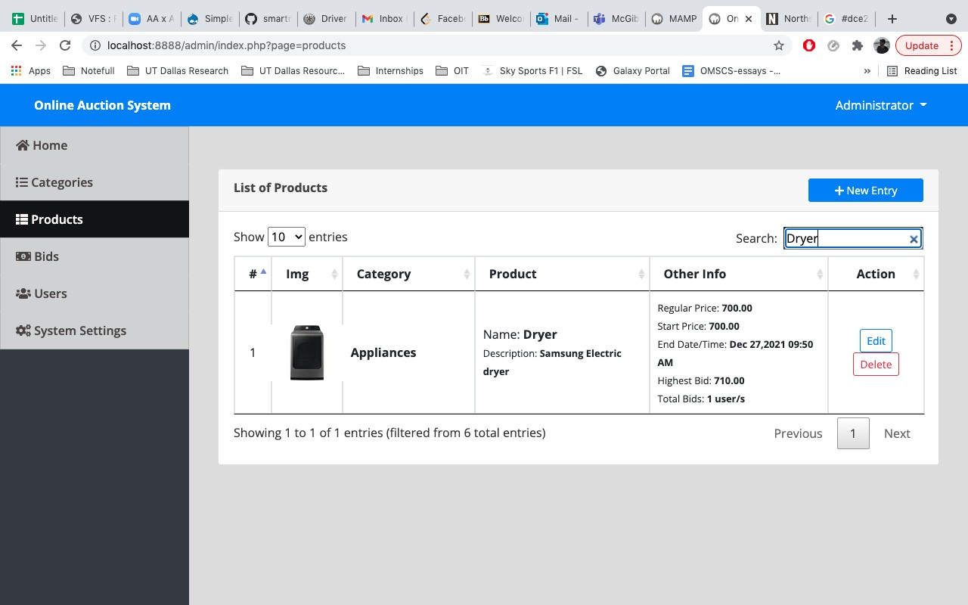

- Edit user information -> Updates the info in USER table
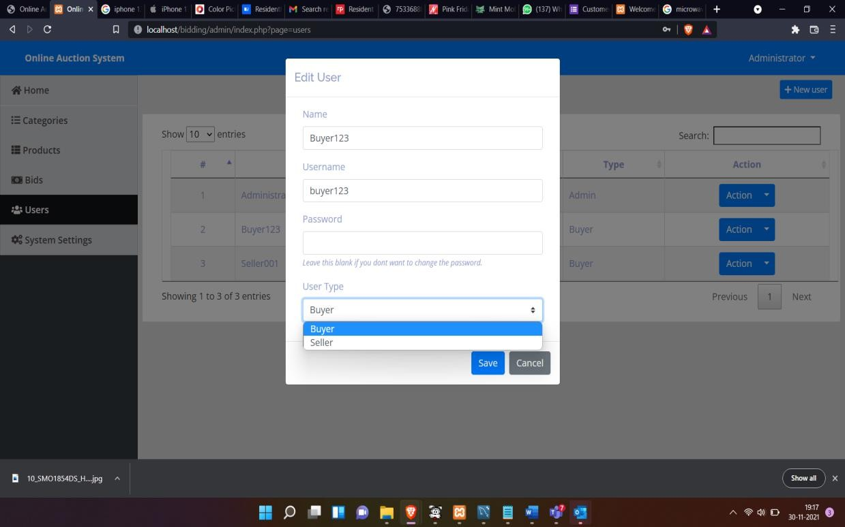

  - View all users -> Retrieves all the records present in USER table
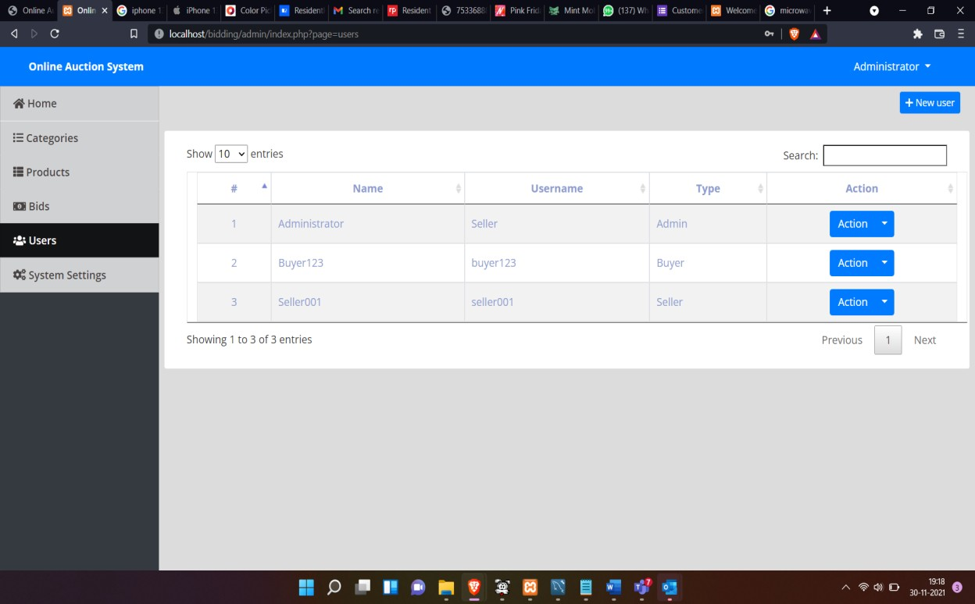

10. Conclusions and Future Work

The project gives a simple representation of Online auction system with basic functionalities like enabling Seller to upload products and users the opportunity to bid on them.

This can be extended to enable users with a better shopping experience by suggesting tailor made products based on shopping history.

11. References

Database manual followed:
https://dev.mysql.com/doc/mysql-installation-excerpt/5.7/en/

MAMP web server installation docs:
https://www.mamp.info/en/downloads/
https://www.mamp.info/en/windows/

PHP+ MYSQL guide:
https://www.w3schools.com/php/php_mysql_intro.asp

Reference text:
Fundamentals of Database Systems (7th Edition)

